Interactive Demos for Amazon Redshift Course

© 2024 Amazon Web Services, Inc. or its affiliates. All rights reserved. This work may not be reproduced or redistributed, in whole or in part, without prior written permission from Amazon Web Services, Inc. Commercial copying, lending, or selling is prohibited. All trademarks are the property of their owners.

Note: Do not include any personal, identifying, or confidential information into the lab environment. Information entered may be visible to others.

Corrections, feedback, or other questions? Contact us at [*AWS Training and Certification*](https://support.aws.amazon.com/#/contacts/aws-training).

**Lab overview**

You use this lab environment to access the AWS Management Console and interact with the AWS services discussed in class. The environment is available to you throughout the day, and it is then reset for the following day’s class.

ICON KEY

Various icons are used throughout this lab to call attention to certain aspects of the guide. The following list explains the purpose for each one:

* **Note:** A hint, tip, or important guidance.

**Start lab**

1. To launch the lab, at the top of the page, choose Start lab.

**Caution:** You must wait for the provisioned AWS services to be ready before you can continue.

1. To open the lab, choose Open Console.

You are automatically signed in to the AWS Management Console in a new web browser tab.

**WARNING:** **Do not change the Region unless instructed.**

COMMON SIGN-IN ERRORS

**Error: You must first sign out**

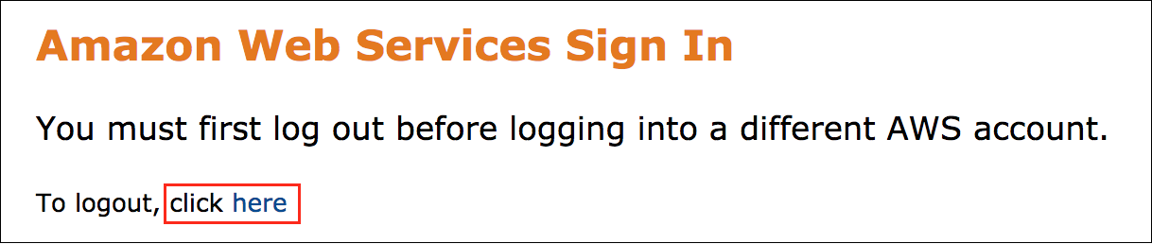

If you see the message, **You must first log out before logging into a different AWS account:**

* Choose the **click here** link.
* Close your **Amazon Web Services Sign In** web browser tab and return to your initial lab page.
* Choose Open Console again.

**Error: Choosing Start Lab has no effect**

In some cases, certain pop-up or script blocker web browser extensions might prevent the **Start Lab** button from working as intended. If you experience an issue starting the lab:

* Add the lab domain name to your pop-up or script blocker’s allow list or turn it off.
* Refresh the page and try again.

ARCHITECTURE DIAGRAM

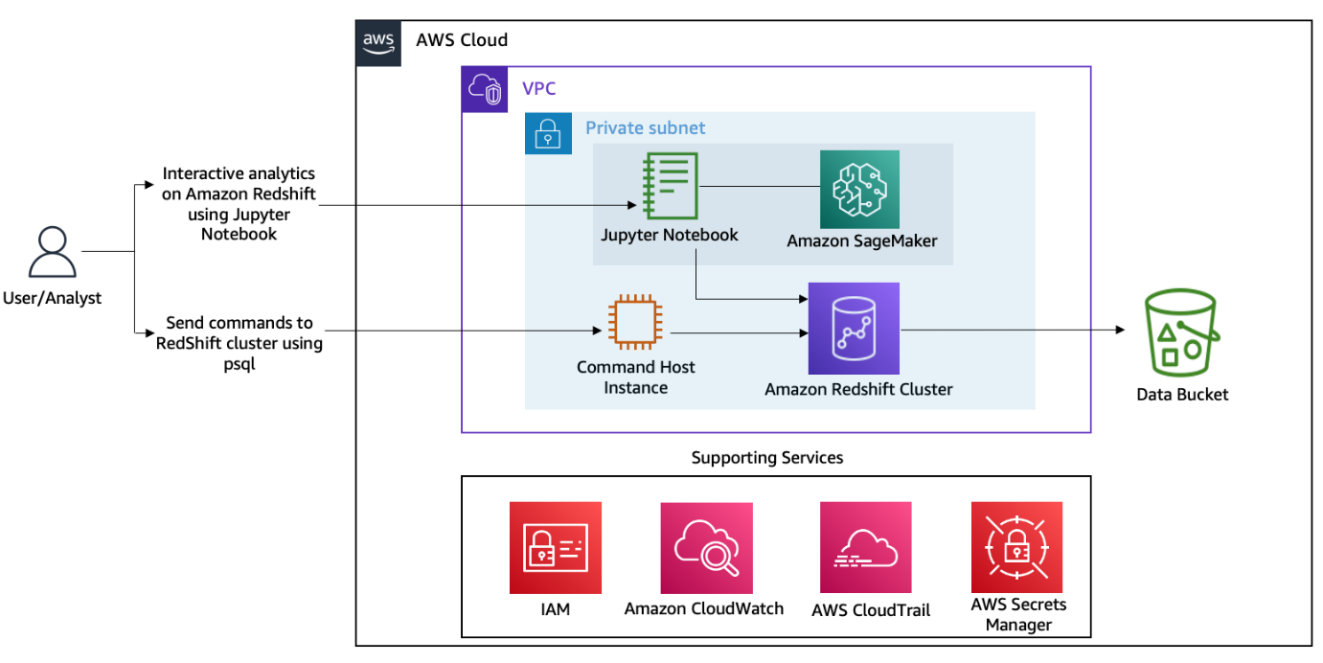

*Image description: The preceding diagram depicts the connection between an external user and Amazon Redshift cluster nodes via a CommandHost EC2 instance within an Amazon Virtual Private Cloud. The external user also connects with an Amazon SageMaker instance via Jupyter Notebook. Lastly, the diagram depicts other supporting services like IAM, Amazon CloudWatch, AWS CloudTrail, and AWS Secrets Manager.*

**Interactive Demo 1: Touring the Amazon Redshift console**

You work with the instructor in this demo. Log in to the AWS Management Console, open the Amazon Redshift console, and tour the console for the following:

* Open the running DC2 cluster
* Identify the node types and number of worker nodes
* Inspect the VPC configuration and its private subnet CIDR address
* View the subnet and parameter groups

CHALLENGE QUESTIONS:

* What is the cluster endpoint URL?
* Is it a publicly accessible cluster?
* How can you integrate the Redshift cluster with partner systems?

**Interactive Demo 2: Connecting your Amazon Redshift cluster using a Jupyter notebook with Data API**

With the Amazon Redshift Data API, any application written in Python, Go, Java, Node.js, PHP, Ruby, and C++ can interact with Amazon Redshift. Traditionally, these applications use JDBC connectors to connect to (and send a query to run and retrieve results from) the Redshift cluster. This method requires extra steps, such as managing the cluster credentials and configuring the VPC subnet and security group.

In this demo, you connect an Amazon SageMaker Jupyter notebook to the Redshift cluster and run Data API commands in Python. You perform the following activities:

* Create a Redshift table from a Jupyter notebook using python Data API
* Load the stock data from an Amazon Simple Storage Service (Amazon S3) bucket
* Query the data from a Jupyter notebook using Data API

First, switch to your Jupyter notebook environment.

Log in to the AWS Management Console and open the Amazon SageMaker console. On the left navigation bar, choose **Notebook instances**. Choose **Open Jupyter**, which takes you to the Jupyter notebook page. Select the **demo2-data-api.ipynb** notebook to complete the demo.

 In this lab, you use SageMaker to launch the Jupyter notebook environment, but SageMaker is not always required. If you have already set up a Jupyter notebook environment, you can continue to use that environment to establish the connection with your Redshift cluster.

**Interactive Demo 3: Applying mixed workload management on Amazon Redshift**

In this demo, you explore the following:

* Automatic WLM
* Concurrency scaling
* Amazon Redshift Advisor
* Query explain plans

QUERY EXPLAIN PLAN

For this demo, you connect to the Redshift cluster database using a Command Host instance and run queries using **psql**. Connect to the cluster with the

 database and

 username.

DIRECTIONS FOR CONNECTING TO THE COMMAND HOST TO USE PSQL

Copy the **CommandHostSessionUrl** value found in the left pane of these instructions into a new browser tab to access the command host terminal. Run the following command on the command host:

* Replace **<INSERT_REDSHIFT_ENDPOINT>** with the value of **RedshiftEndpoint** found in the left pane of these instructions.

psql -U dbadmin -h '<INSERT_REDSHIFT_ENDPOINT>' -d demolab -p 8192

Once connected to the **demolab** database, copy and paste the following query using the psql prompt, and then run the query. (This query searches highest stock price trades for all the stocks.)

explain select a.ticker, a.trade_date, '$'||a.adj_close as highest_stock_price

from stocksummary.stocks a,

(select ticker, max(adj_close) adj_close

from stocksummary.stocks x

group by ticker) b

where a.ticker = b.ticker

and a.adj_close = b.adj_close

order by a.ticker;

Review the explain plan with the instructor.

QUERY PLAN

--------------------------------------------------------------------------------------------------------------------------------

XN Merge (cost=1000015005413.89..1000015005414.03 rows=56 width=36)

Merge Key: a.ticker

-> XN Network (cost=1000015005413.89..1000015005414.03 rows=56 width=36)

Send to leader

-> XN Sort (cost=1000015005413.89..1000015005414.03 rows=56 width=36)

Sort Key: a.ticker

-> XN Hash Join DS_BCAST_INNER (cost=1623.89..15005412.27 rows=56 width=36)

Hash Cond: (("outer".adj_close = "inner".adj_close) AND (("outer".ticker)::text = ("inner".ticker)::text))

-> XN Seq Scan on stocks a (cost=0.00..1082.30 rows=108230 width=36)

-> XN Hash (cost=1623.76..1623.76 rows=25 width=51)

-> XN Subquery Scan b (cost=1623.45..1623.76 rows=25 width=51)

-> XN HashAggregate (cost=1623.45..1623.51 rows=25 width=22)

-> XN Seq Scan on stocks x (cost=0.00..1082.30 rows=108230 width=22)

**Interactive Demo 4: Amazon Redshift cluster resizing from the *dc2.large* to *ra3.xlplus* cluster**

As your data warehousing capacity and performance needs change or grow, you can resize your cluster to make the best use of the computing and storage options that Amazon Redshift provides.

Switch back to the browser tab open to the Amazon Redshift console. From the cluster’s detail page, select the **Actions** dropdown, and then select the *Resize* option. For the next step, there are two ways you can resize a cluster: Elastic and Classic. With any resize, you can change the node type, number of nodes, or both. This lab originally provisioned with a dc2 node type, and dc2 nodes only support classic resizing. So, select the *Classic resize* option. In the **Node type** dropdown, select the *ra3.xlplus* node type. Type the number

 in the **Nodes** text area. Choose **Resize cluster** to change the cluster from *dc2.large* to *ra3.xlplus*. Depending on the cluster data, the resize typically completes in 10-15 minutes.

**End lab**

Follow these steps to close the console and end your lab.

1. Return to the **AWS Management Console**.
2. At the upper-right corner of the page, choose **AWSLabsUser**, and then choose **Sign out**.
3. Choose End lab and then confirm that you want to end your lab.